Guide for Reviewers
Guide for Reviewers of Blood Cell Therapy in one document (PDF).

All submitted manuscripts are initially assessed by the Editor-in-chief for suitability to our journal. Afterwards, a peer review is conducted to have the submitted manuscript be assessed by experts in the relevant research field. In order to review the manuscript in a manner that is appropriate and fair, there are three very important things to consider before reviewers accept the invitation to the peer review process:
1) Conflict of interests
Presence of a conflict of interest does not necessarily disqualify you as a reviewer, but it is important to declare any potential conflict of interest in the “Anonymized comments to the Editor” box in the on-line reviewing system. If you have any concerns, do not hesitate to contact the editorial office.
2) Competence: Your field of expertise
If you are not confident that your field of expertise can cover the content of the manuscript for review, contact the editorial office as soon as possible. If you have an alternative reviewer whose expertise you believe will match the manuscript, please let us know.
3) Confidentiality
All submitted manuscripts, including supplements, must be handled confidentially. Reviewers must not disclose content to anyone until the manuscript is published. Reviewers must not retain a copy for any kind of personal purpose; all copies must be destroyed in an appropriate manner immediately after the review process.

General attitude for review
Reviewers are expected to promptly submit their reviews within the predetermined deadline. First, please evaluate whether the submitted manuscript meets the scope of Blood Cell Therapy. Always bear in mind that the reviewer should provide constructive, objective, honest, helpful, and polite comments so that the author will be able to improve their manuscript. Finally, reviewers are expected to refrain from making hostile or derogatory comments.

The peer review process
1) Use of the on-line review system
Blood Cell Therapy has adopted the ScholarOne online system.
Information for reviewers on the use of the system can be found at:
http://mchelp.manuscriptcentral.com/gethelpnow/training/reviewer/

Candidate reviewers that are invited by e-mail are asked to select the appropriate hyperlink for sending their response to the journal (please see the Workflow below). If you select the “Agreed” hyperlink, you will receive an additional e-mail that contains a link to your reviewer center. Thereafter, follow the guidance that appears in the web page. If you have any further questions, please see the web page in the above link for more detailed information.

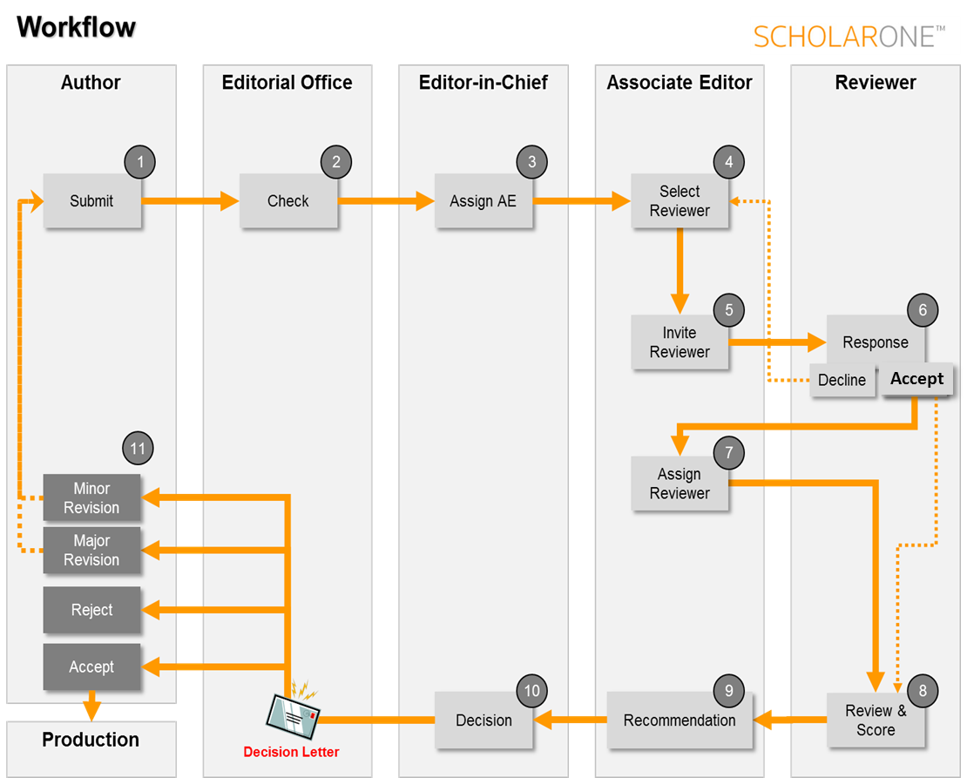

2) Scoring the assigned manuscripts

Does the manuscript contain new and significant information to justify publication?
Is the problem significant and concisely stated?
Are the interpretations and conclusions justified by the results?
Is adequate reference made to other work in the field?
Is the language acceptable?

Yes. No, Not Applicable

Please state any conflict(s) of interest that you have in relation to the review of this paper (state “none” if this is not applicable).

After a successful log-in, a score sheet will be opened. There you will find categories for rating, a “Recommendation field,” “Confidential Comments to the Associate Editor,” and “Comments to the Author.”

At the top, you are asked to score the submitted manuscript from the following five points of view: “Novelty,” “Concise and clear presentations,” “Justification of conclusions,” “Adequate references,” and “Quality of English writing,” by using the following ratings: Yes, No, and Poor. For more information, please see below − “In addition, attention should be paid to each part of the manuscript” −.

Next, you are asked to disclose your potential conflict of interest.

Third, you are asked to score the submitted manuscript from the following four points of view: “Importance,” “Quality,” “Originality,” and “Overall,” by using the following ratings: Excellent, Good, Average, Below Average, and Poor.
● Importance: Articles of importance must help our readers (and potential general readers) to update their knowledge, to make better clinical decisions in their practices, and to inspire readers to raise the next research questions.
● Quality: Articles that are of good quality refer to reports of research that have been conducted with careful and logical design, offer objective analyses with sound statistics, and are verifiable and replicable by others. Quality also consists of the adequate use of written English that clearly informs the reader of what the author intended to convey.
● Originality: Articles with originality must include findings that are sufficiently novel to what has been shown in previously published literature.
● Overall: Comprehensive evaluation with the above factors considered, alongside others.
Next, reviewers are encouraged to convey their own decision to the editors by selecting what is deemed appropriate from the following: Accept, Minor Revision, Major Revision, and Reject.

3) Describing your comments and submission of your total evaluation

Finally, reviewers are asked to report their comments using the Comments box. We use the single-anonymized review system where reviewers can recognize the author of the manuscript while remaining anonymous. The outline of this process is listed as follows:

● “Confidential Comments to the Editor” box
If you have confidential comments for the editor, write them in this box.
Examples of comments could be:
(i) Any suspicion of ethical issues such as plagiarism, duplicate submission, unrevealed conflict of interest related to authors, human subjects, or animal welfare.
(ii) Reason for your recommendation (accept, major/minor revision, reject).
(iii) Concerns regarding the authorship, the experimental design, wrong statistical tests, or violation of law.

● Comments to the author
(i) It is advisable to first summarize the main findings as addressed in the manuscript, which helps the editor(s) understand the key points of the manuscript and helps the authors to understand the reviewer’s interests and concerns to the manuscript. However, refrain from the provision of a statement of recommendation for acceptance or rejection.
(ii) Divide your comments into major/essential and minor ones, where the former is critical for acceptance of the manuscript.
(iii) Organize your comments by numbering.
(iv) Cite relevant prior work to your comments to support your criticism.
(v) Refer to the relevant guidelines (clinical trials, statistical analysis, or microarray experiments, etc.) that may affect the contents.

● In addition, attention should be paid to each part of the manuscript, as below:
(i) Title: Is it informative enough to indicate the contents?
(ii) Abstract: Is it well-organized and summarized within the word limits in accordance with the type of the article?
(iii) Introduction: Is it concise, and does it clearly provide the purpose and the rational of the study as based on previous reports? Does the research article convey the authors’ hypothesis or the concept of the study?
(iv) Materials and Methods: Do they provide sufficient information clearly so that the results can be repeated/reproduced by other researchers? If necessary, further information can be requested as supplementary data.
(v) Results: Are they clearly presented following a short introduction and description of the methods used? Are figures and/or tables necessary and sufficient? Is each figure self-explanatory with sufficient captions?
(vi) Discussion: Is it concise enough and relevant to their results? Has the hypothesis or concept been justified by the data obtained? Is the conclusion logical and sound? Are unexpected results fully accounted for by the authors? Do they present the merits and limitations of their study for future studies?
(vii) References: Does the reference list adhere to our journal requirements?

4) Editor’s final decision
The Editor-in-chief makes the final decision, taking into consideration the reviewers’ comments and the Associate Editor’s suggestions. The decision letter will be sent to the corresponding author, reviewers, and Associate Editor(s) via an e-mail from the online system.

